Full Stack Development with MERN

Project documentation Formate

1.Introduction

- Project Title : Shopez e- commerce application
- Team Members: charitha vinukonda (individual)

2.Project Overview

- Purpose: A safe, risk-free web app to practice buying and selling stocks with fake money.
- Features:
- Secure Login: Protects user accounts.
- $100,000 Fake Cash: Given to every new user to start trading.
- Stock Charts: Easy-to-read charts that show stock price changes.
- Trade Log: Keeps a clean history of every buy and sell.
- Admin Page: Allows admins to add or remove stocks.
3. Architecture
- Frontend (React): Drives what the user sees, handles buttons, and draws the charts.
- Backend (Node.js & Express): Works behind the scenes to process trades and verify users
- Database (MongoDB): Saves user details, cash balances, and trade history
.

4. Setup Instructions

Prerequisites
Make sure you have Node.js and MongoDB installed on your computer before starting.
- Installation Step-by-Step Setup
For Backend:
- Open your terminal or command prompt and run these commands to download the project and enter its folder:git clone https://github.com/yourusername/stock-trading-platform.gitcd stock-trading-platform

Go into the backend folder:cd backend
- Install all required code packages:npm install
- Create a new file named .env in this backend folder and paste the following text inside it:PORT=5000MONGO_URI=mongodb://localhost:27017/stock_dbJWT_SECRET=mysecretkey
For Frontend:
- Open a new, separate terminal window, go to the main project folder, and then enter the frontend folder:cd frontend
- Install the visual and layout packages:npm install
- Create a new file named .env in this frontend folder and paste the following text inside it: REACT_APP_API_BASE_URL=http://localhost:5000/api
Run the Application
- In your Backend Terminal (from Step 2), run:npm start
- In your Frontend Terminal (from Step 3), run:npm start
Once both are running, open your web browser and go to:

5.Folder Structure

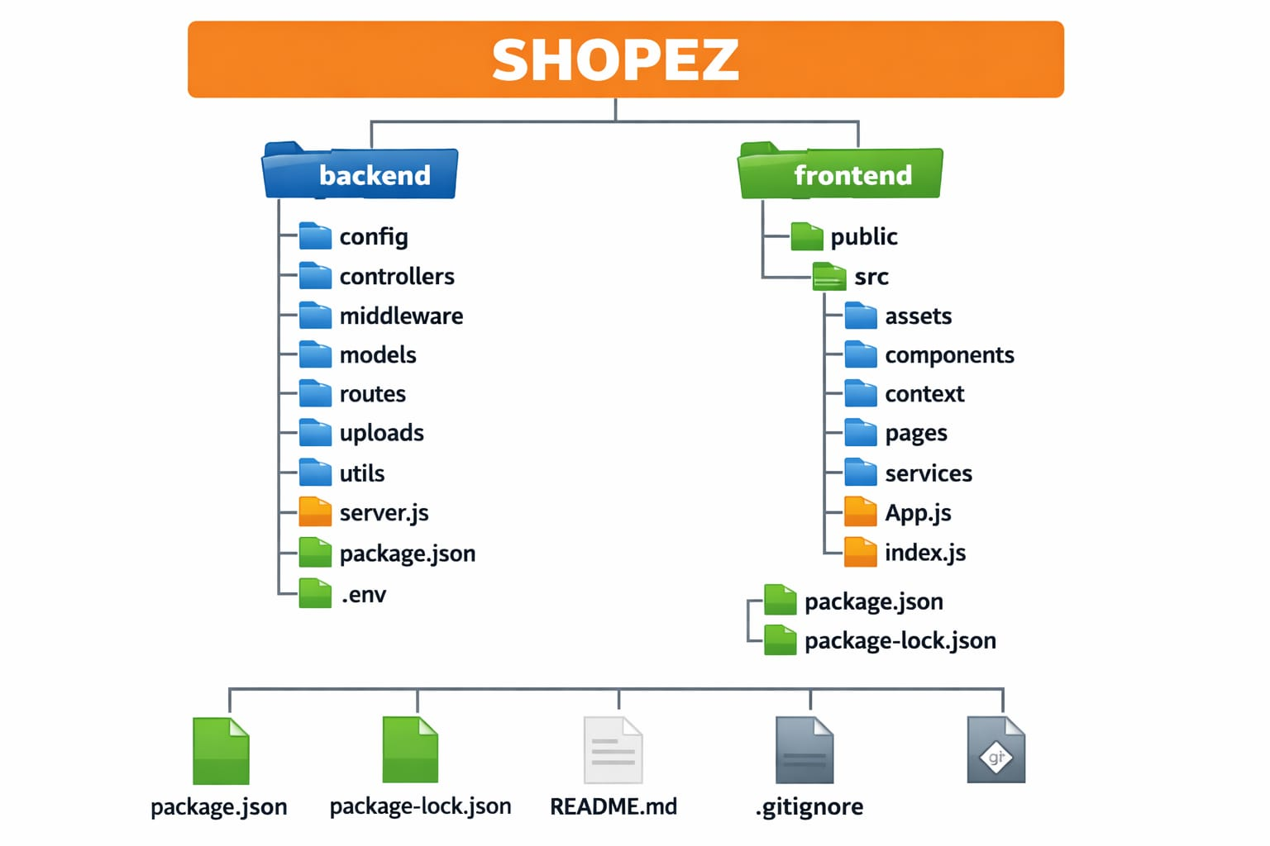

6. Running the Application

1. Start the Backend (Terminal 1)
cd backend
npm start

2. Start the Frontend (Terminal 2)
cd frontend
npm start
- Go to http://localhost:3000 in your web browser to view the app.

7. API Documentation

Users & Security
- POST /api/auth/register — Sign up a new user.
- POST /api/auth/login — Log in and get a security token.
- Trading
- GET /api/portfolio — Get your current cash balance and owned stocks.
- POST /api/trades/execute — Buy or sell a stock.

Example Trade Input (POST request):
{
"symbol": "AAPL",
"type": "BUY",
"quantity": 5
}

Example Trade Output (200 OK response):
{
"success": true,
"message": "Bought 5 shares of AAPL",
"newBalance": 99125.00
}

8. Authentication

- Password Safety: We use bcryptjs to encrypt passwords before saving them. We never store plain text.
- Security Key (JWT): Once you log in, the server gives your browser a secure text key. Your browser sends this key with every action to prove who you are.

9. User Interface
- The UI uses simple, dark-themed dashboard cards to show stock data clearly.

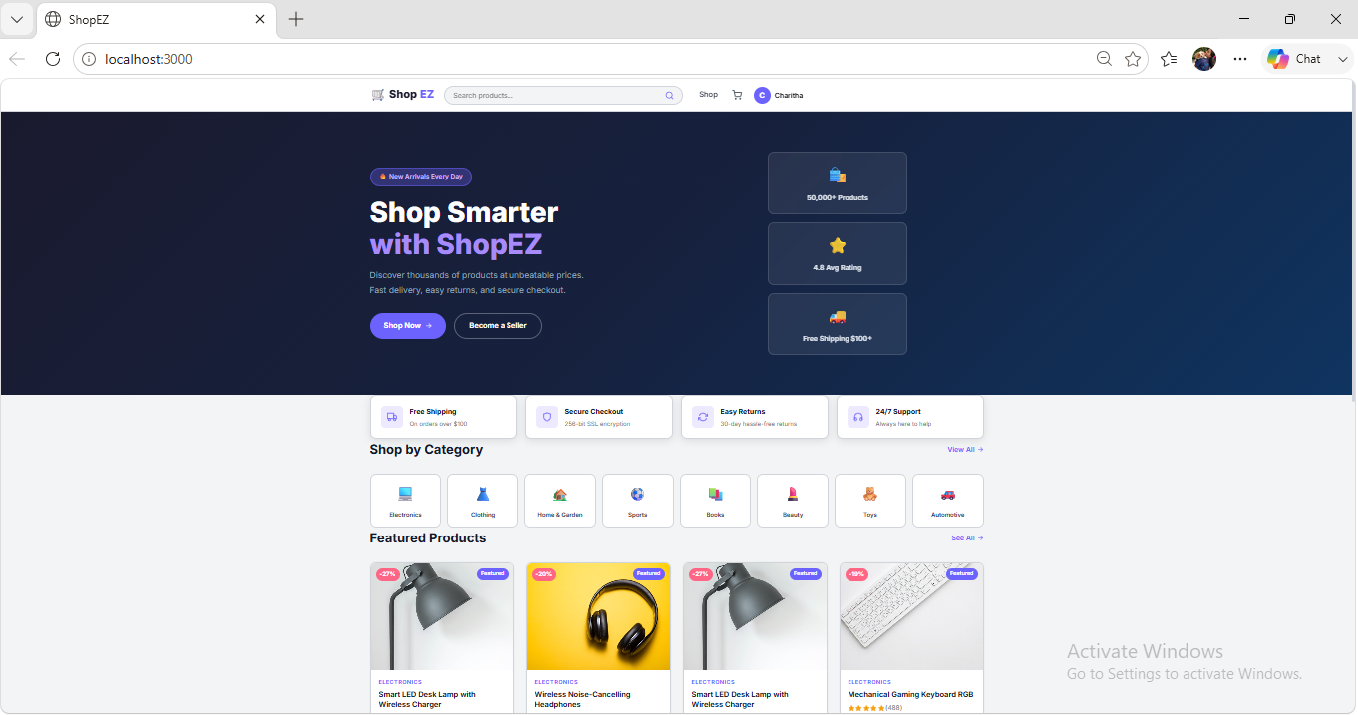

10. Testing

- Automatic Tests: We use Jest to make sure basic tasks work (like blocking trades if a user does not have enough cash).
- Manual Check: We test inputs by hand to make sure emails cannot be registered twice and that regular users cannot access admin pages.

11. Screenshots or Demo

Demo Link: https://drive.google.com/drive/folders/1PeO7eV0swR8ZRgDB5hczLmiOpj5n_OPA

12. Known Issues

- Slow Price Updates: Stock prices update every 10 seconds. They are not perfectly instant.
- Free API Limits: The free stock price service only allows 25 chart loads per day before it pauses.

13. Future Enhancements

- Live Prices: Use WebSockets to show prices changing instantly.
- Favorites List: Let users create a "watch list" of stocks they care about.
- Add Funds: Create a button to let users reset or add fake money to their balance.

